LEVY RETURNS:

In this sample we are assuming that the client has received the following invoice and has now rejected 2000 of the original count. For illustration purposes we will further assume that we are returning 2000 to inventory, sorting the product and re-shipping 1800. This is the original invoice:
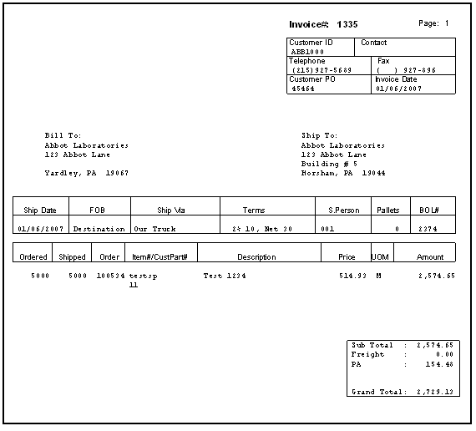

Start the process by going to O-L-1 , Levy Returned goods.

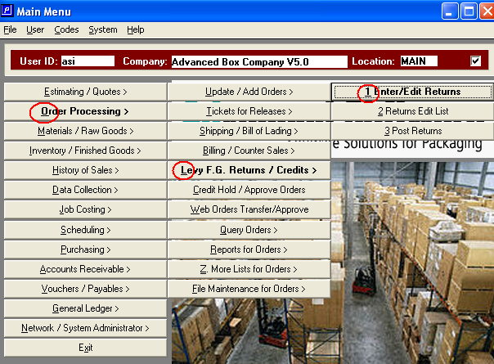

Select the “+” key to enter a new return:
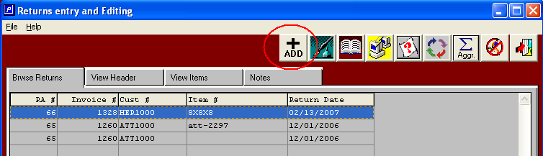

Enter the invoice number of the item that is being returned:
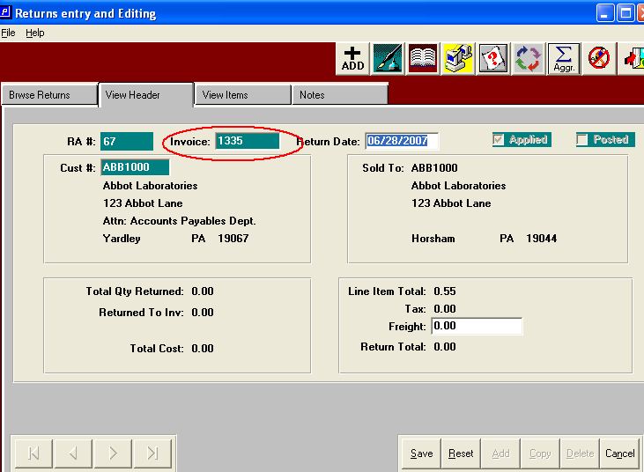

Enter the item from that invoice that is being returned. (An F1 will pop-up all invoice line items).
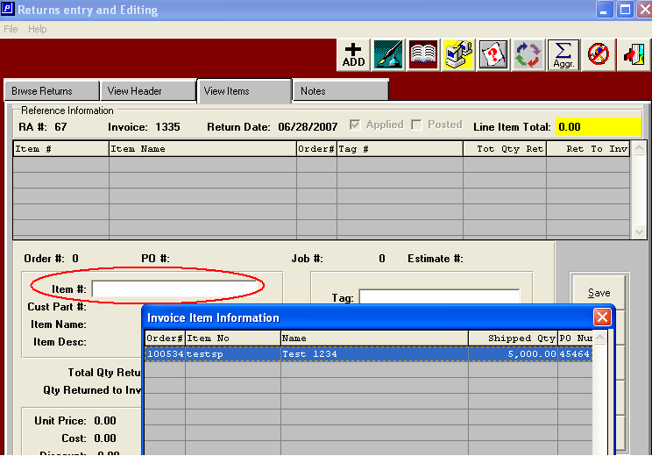

Select the tag number (s) of this item that are being returned. (F-1 on the Tag field to display tags for this item). If you do not use inventory tags (unique load tag numbers) the tag number is left blank.
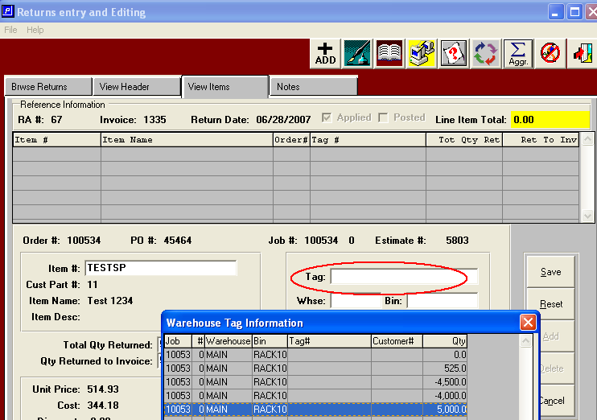

Now you can key in the quantity that is being returned and the quantity that you are going to re-bill to the client.
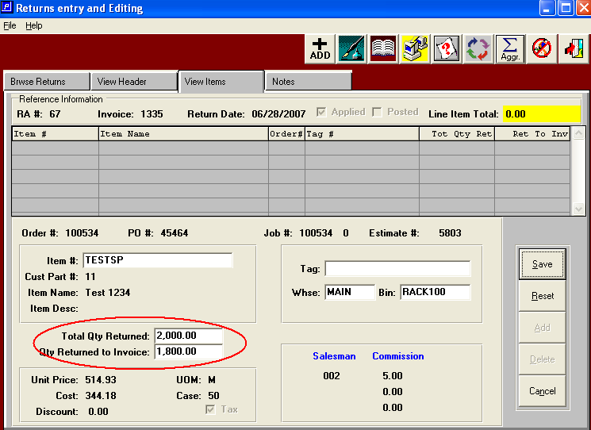

You can use the “notes” tab to key in the reason for the return.
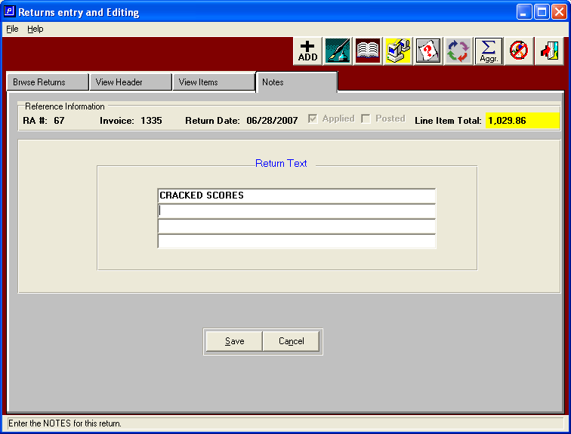

Print the edit list to check your work. Then post the returns.
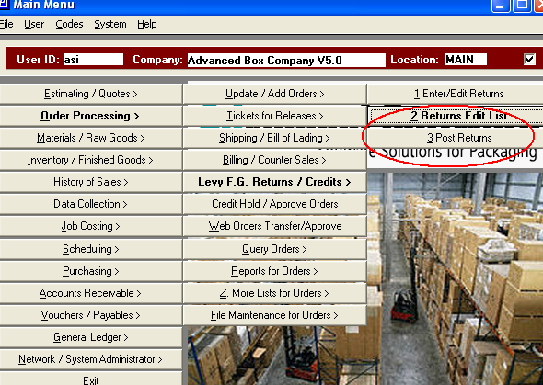

Now if you go to I-U-1 you will see that the system has created a finished goods receipt that is ready to be posted. Once it is posted the 2000 returned boxes will be back in inventory.
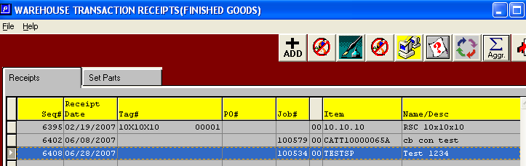

If you go to A-W-1 you will see that the credit memo creation has been generated for the returned goods.
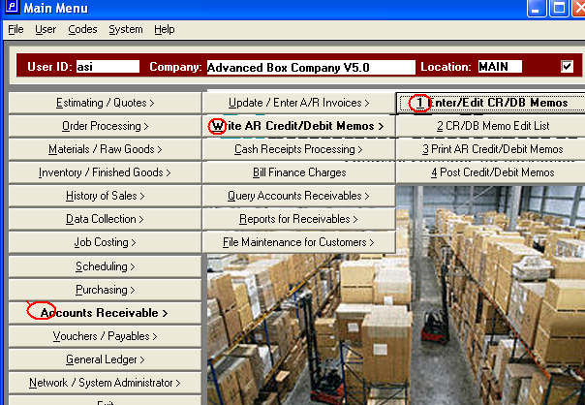

The information form the LEVY RETURNED GOODS has created the credit memo input. Now you just need to print and post the credit memo.
